Fried Catfish

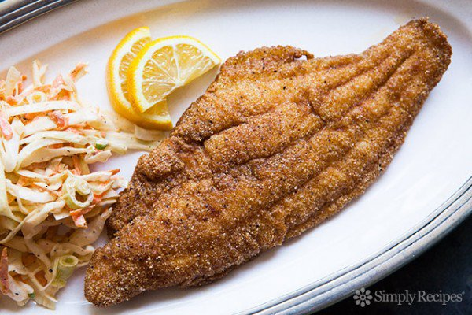[Larger photo](javascript:void(0);)

*This frying method works with pretty much any thin fish fillet: If you can't find catfish, use tilapia, bass, flounder, walleye, perch, rockfish, croaker or black seabass.*

* **Prep time:** 10 minutes
* **Cook time:** 10 minutes
* **Yield:** Serves 4.

**INGREDIENTS**

* 4-6 catfish fillets, about 1-2 pounds
* 1 cup milk or buttermilk
* Salt
* 3/4 cup fine cornmeal (do not use coarsely ground cornmeal)
* 1/2 cup flour
* 1 teaspoon garlic powder
* 1 teaspoon black pepper
* 1 teaspoon paprika
* 1/2 teaspoon cayenne
* 1/4 teaspoon celery seed
* Oil for frying (use peanut oil if you can)

**METHOD**

**1** In a heavy frying pan (I prefer to use cast iron), pour enough oil to come 1/2 inch up the sides of the pan. Turn the heat to medium-high. Turn your oven to 200° and lay a cookie sheet inside. Place a wire rack on top of the cookie sheet.

**2** While the oil is heating, soak the catfish in the milk or buttermilk. Mix the cornmeal, flour and spices together. (Or you can substitute your favorite seasoning instead.) Let the oil reach 350 degrees — a good test is to flick a little of the dry breading into the oil, and if it sizzles at once, you're good to go.

**3** Once the oil is hot, sprinkle the catfish fillets with salt and dredge them into the breading. Shake off the excess and gently lay into the hot oil. Fry until golden brown, about 2-4 minutes, depending on how thick the fillet is. Use a metal spatula and gently turn the fish over and cook for another 2-4 minutes. Cast iron heats up and stays hot, so monitor the heat as you fry; you may need to lower the heat on the burner at some point.

**4** Once the fish is ready, move it to the oven while you cook the rest of the catfish. Keeping the fried catfish warm in the oven will help keep it crispy. When they're all done, serve at once with your favorite hot sauce, cole slaw and some hush puppies.